Validation Testing

- Here are some creations I tried to replicate with my program:

  - FC Bayern Munich
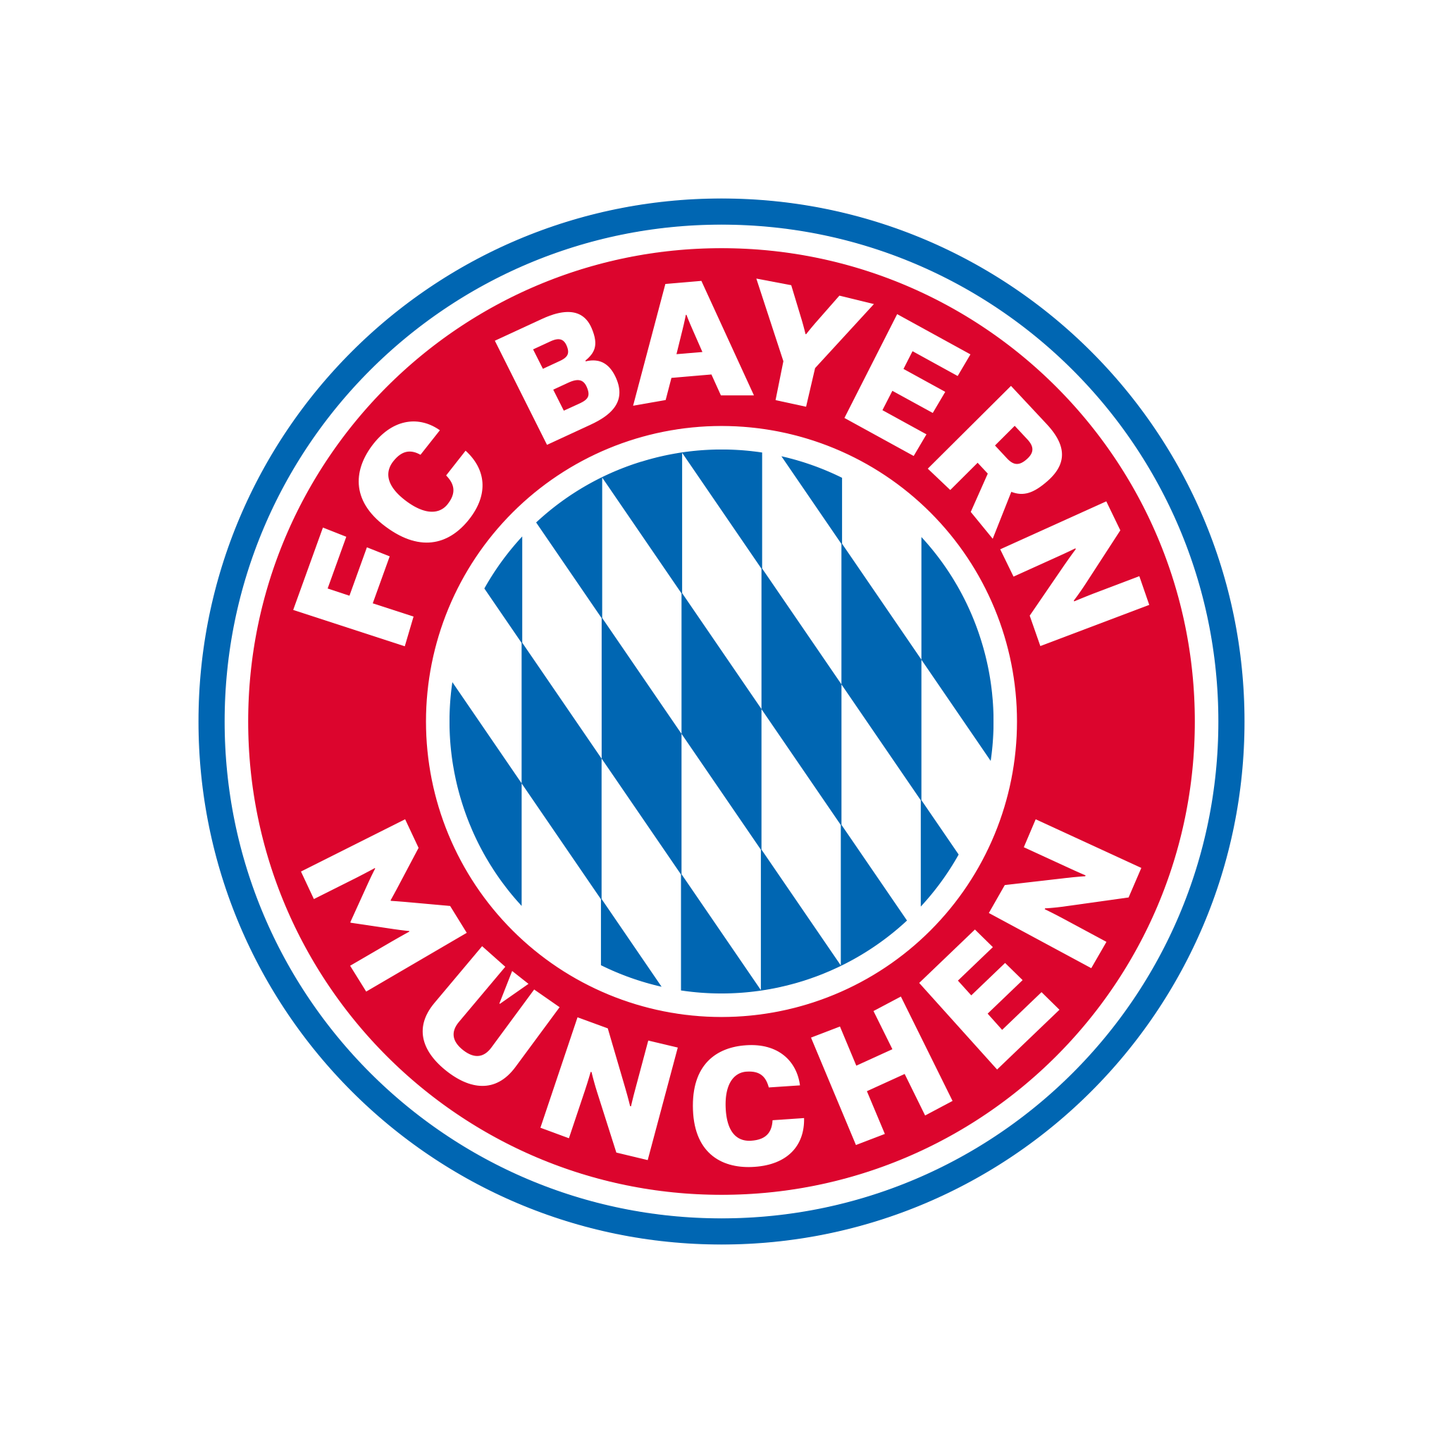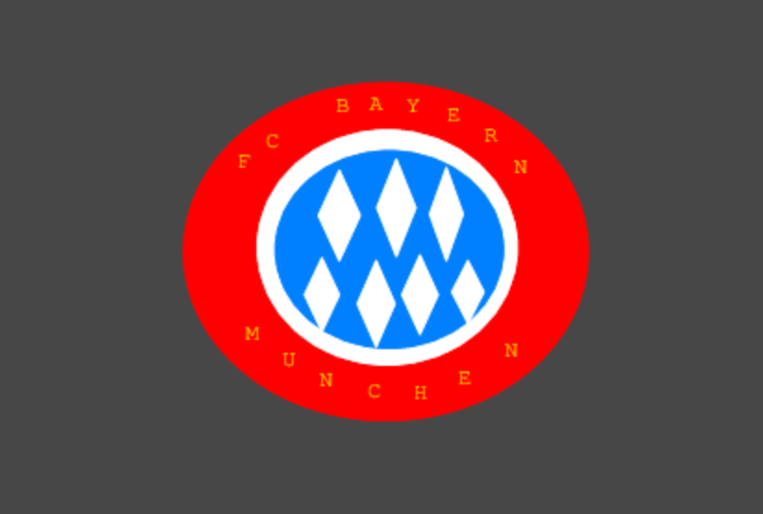

  - Domino’s
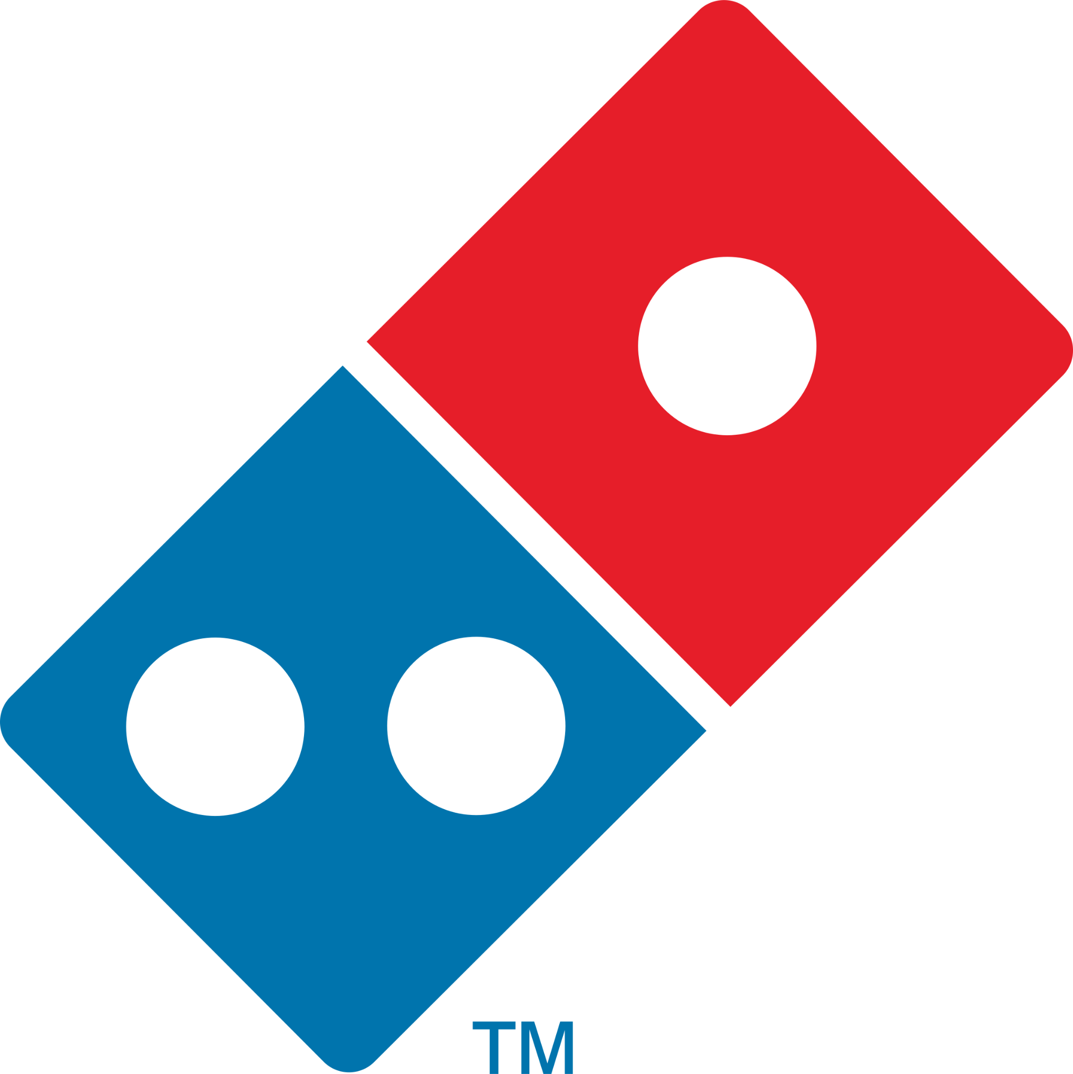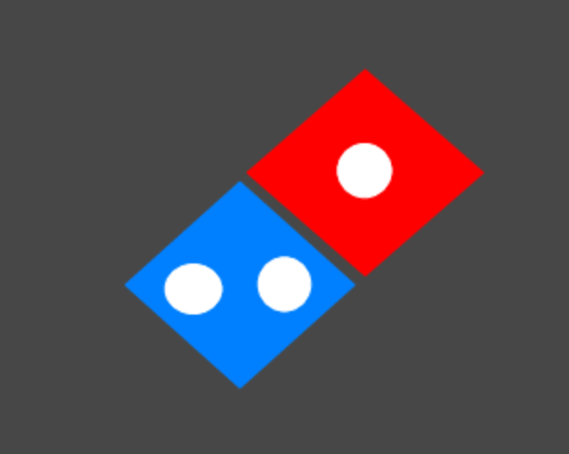

  - Mickey Mouse
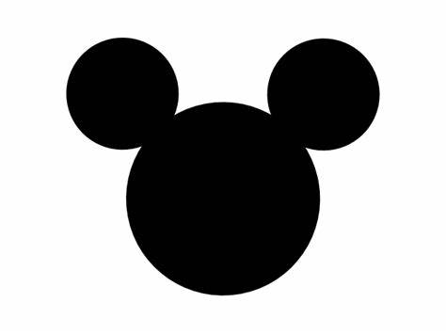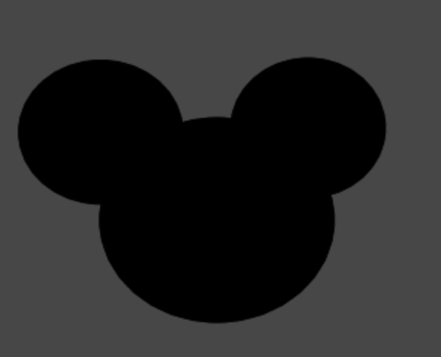

- There were 2 data sets I tested against my program to see what happens:
  - How the color White appears onto my canvas
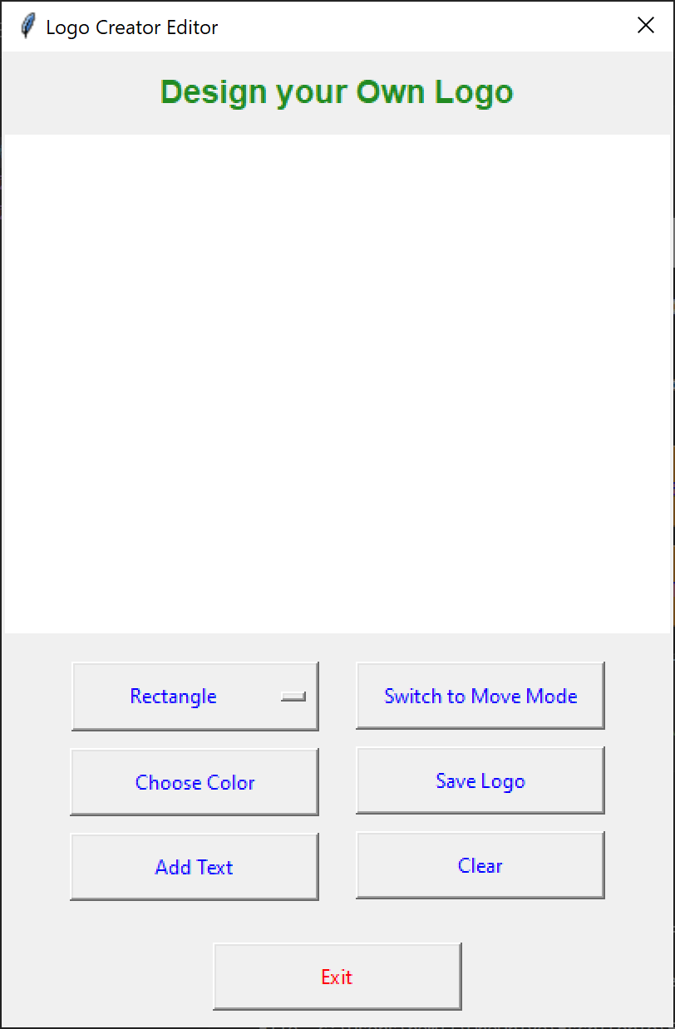
As we can see, it appears to be nothing on the canvas but after saving and downloading the image:

There actually has been a star this entire time, it was hidden this entire time.
In order to fix this, I decided to draw a black rectangle that covers the entire canvas:
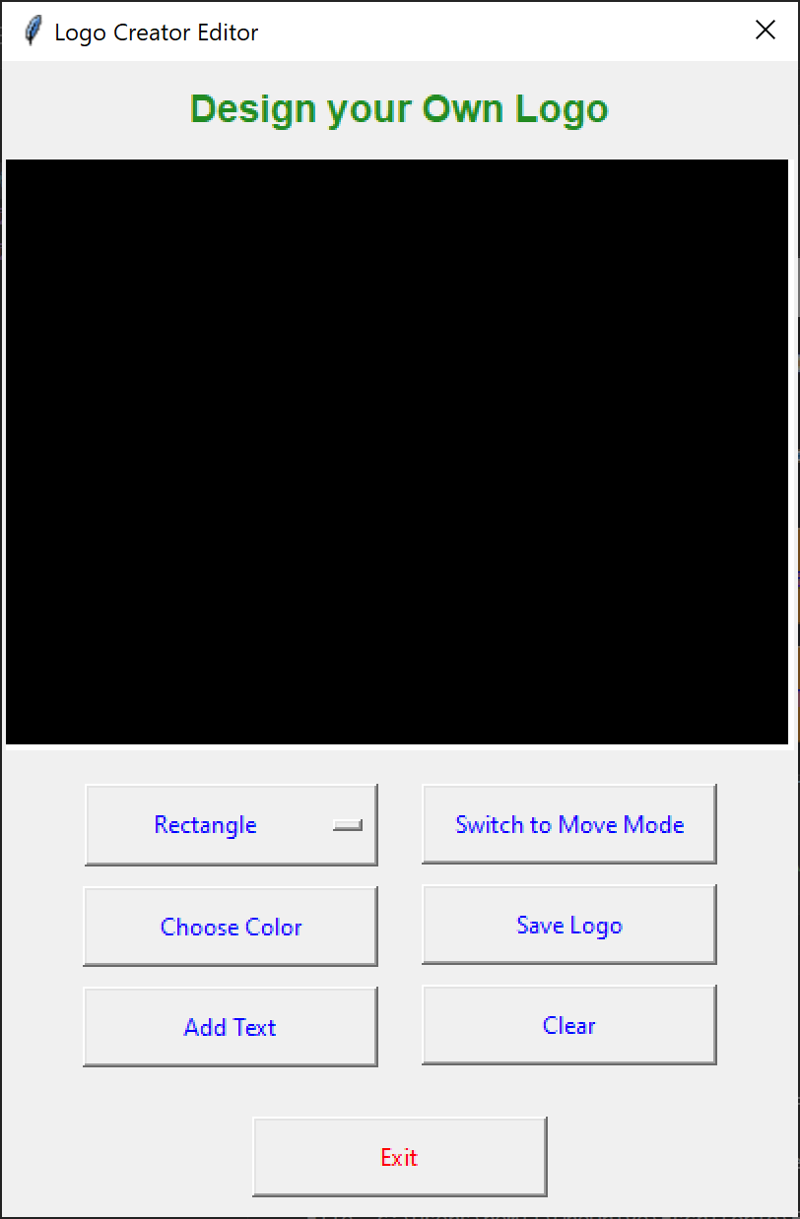
And low and behold, my white star is able to be seen.


  - Ability to create multiple windows of the Creating Logo window
This test was performed due to myself encountering an issue while trying out my app.
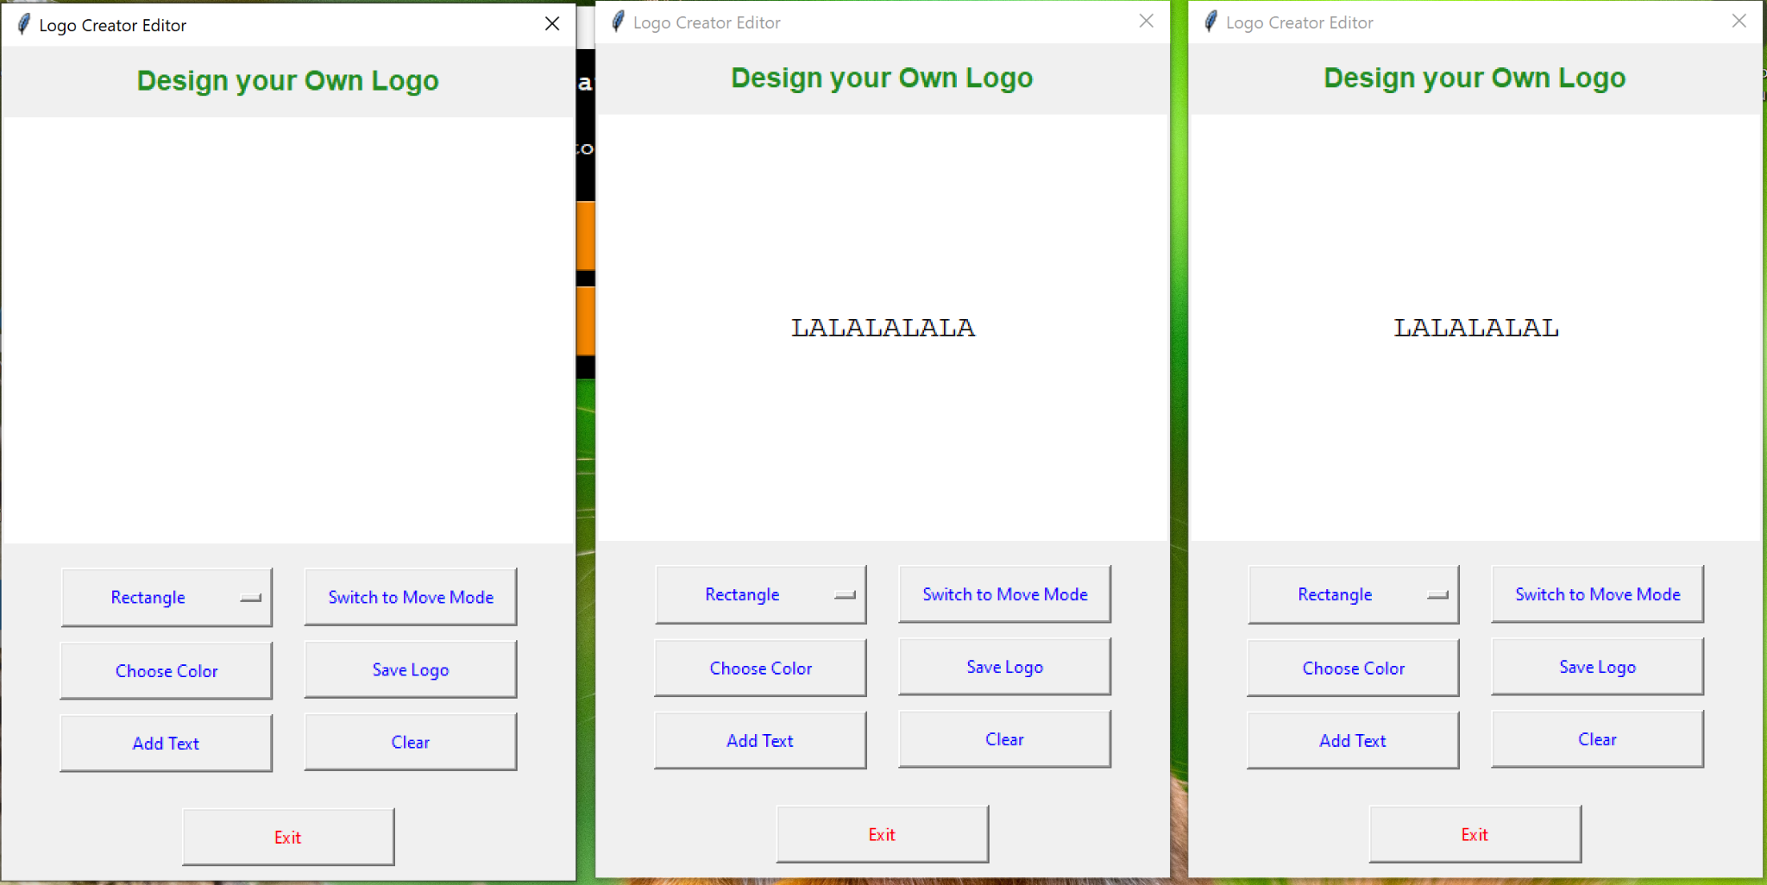
After adding the text, I clicked on the main window by accident and it allowed me to click on “Open Logo Creator” and open the same window again. Obviously, this is a very big problem as I do not want this to happen whatsoever.
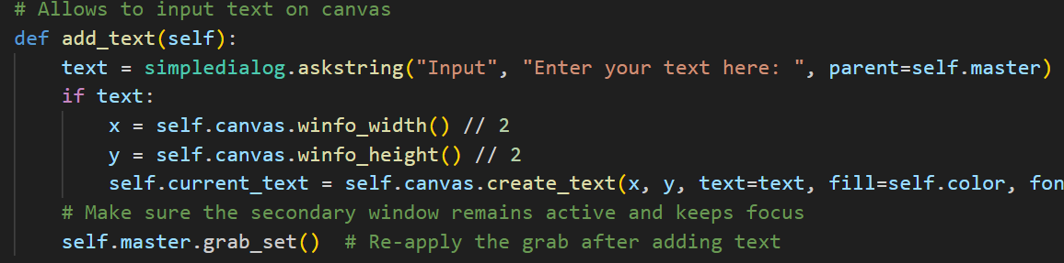
By adding the parent=self.master and self.master.grab_set(), it ensures that I don’t have access to the Main Window at all. It’s proven as you use my app that this issue is no more.

